Hi Alex

I connected singal port in LLD Board base on your diagram you sent me, but problem has not resolved

I checked motherboard and I got results as below:

|  |  |  |
| --- | --- | --- |
| PIN |  | Results |
| 1 | Red | -2 V |
| 2 | Yellow | 2 V |
| 3 | Blue | 5 V |
| 4 | Black | 0 V |
| 5 | NA |  |
| 6 |  |  |
| 7 |  |  |

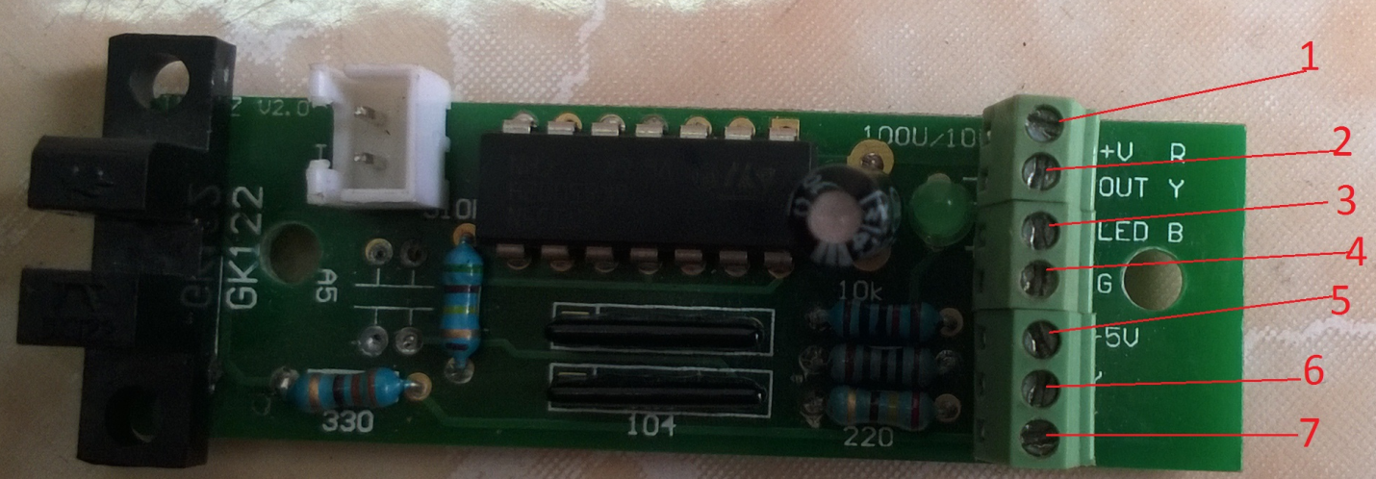

Alex help me please, If you can, you guides me how to check motherboard that supply electric for metallic circuit